ECG AND PULSE -OXIMETER

A report submitted in partial fulfilment of the requirements for the award BACHELOR OF TECHNOLOGY

In

Electronics and communication Engineering

S .AMEENA (20FE1A04E1) T.LAHARI(20FE1A04H1) P.AKASH(20FE1A04C6) T.VAMSI(20FE1A04H0)

Open-Source Hardware Tools for Electronics engineers

(skill Oriented Course)



DEPARTMENT OF ELECTRONICS AND COMMUNICATION ENGINEERING

VIGNAN’S LARA INSTITUTE OF TECHNOLOGY & SCIENCE

(Approved by AICTE and affiliated to JNTUK Kakinada, Accredited by NBA )

VADLAMUDI POST, GUNTUR DISTRICT-522213

SEPTEMBER 2022

**DEPARTMENT OF ELECTRONICS AND COMMUNICATION ENGINEERING**

**VIGNAN’S LARA INSTITUTE OF TECHNOLOGY & SCIENCE: VADLAMUDI**



CERTIFICATE

This is to certify that the mini project titled “ECG AND PULSE -OXIMETER” is a bona fide record of work done by T. LAHARI (20FE1A04H1), S. AMEENA (20FE1A04E1), P. AKASH (20FE1A04C6), T. VAMSI (20FE1A04H0) as part of the skill oriented course open-Source Hardware Tools for Electronics Engineers in partial fulfilment of the requirement of the degree for Bachelor of Technology in Electronics and communication Engineering during the academic year2022-23

MR. K. DAYANAND DR. B. HARISH

Course Coordinator HEAD OF THE DEPARTMENT

DECLARATION

We, T. LAHARI (20FE1A04H0), S. AMEENA (20FE1A04E1),

T. VAMSI (20F1A0456), P. AKASH (20FE1A04C6) hereby declare that the report entitled ”ECG AND PULSE-OXIMETER” is done by us as part of the Skill Oriented Course Open-Source Hardware Tools for Electronics Engineers in partial fulfilment of the requirement of the degree for Bachelor of Technology in Electronics and Communication Engineering during the academic year 2022-2023 .

DATE:

PLACE: VIGNAN’S LARA INSTITUTE OF TECHNOLOGY & SCIENCE, VADLAMUDI

SIGNATURE OF THE CANDIDATES

S. AMEENA (20FE1A04E1)

T. LAHARI (20FE1A04H1)

T. VAMSI (20FE1A04H0)

P. AKASH (20FE1A04C6)

ACKNOWLEDGEMENT

We also place our floral gratitude to all other teaching staff and lab We thank Dr.K. Phaneendra Kumar, principal, Vignan’s Lara institute of technology, Vadlamudi, for providing us the resources for carrying out the project.

Our sincere thanks to Dr. B. Harish, Head, Department of ECE, for his co-operation and guidance which helped us to make our project successful and complete in all aspects.

We also express our sincere thanks and are grateful to our course coordinator MR.K.DAYANAND, Assistant Professor of Department of ECE, for motivating us to make our project successful and fully complete. We are grateful for their precious guidance and suggestions.

We also place our floral gratitude to all other teaching staff and lab technicians for their constant support and advice throughout the project.

NAME OF THE CANDIDATE:

S. AMEENA (20FE1A04E1)

T. LAHARI (20FE1A04H1)

T. VAMSI (20FE1A0H0)

P. AKASH (20FE1A04C6)

CONTENTS:

* ABSTRACT
* INTRODUCTION
* COMPONENTS REQUIRED
* WORKING PRICIPLE
* SOURCE CODE
* ADVANTGES AND APPLICATIONS
* ADVANCEMENTS
* EXPECTED RESULT
* CONCLUSION

ABSTRACT

* The aim of the ECG is to detect the abnormal heart rhythms
* An ECG is to help diagnose and monitor conditions affecting the heart. It can be used to investigate symptoms of a possible heart problem, such as chest pain, palpitations, dizziness and shortness of breath.
* Pulse oximetry is a test used to measure the oxygen level (oxygen saturation) of the blood. It is an easy, painless measure of how well oxygen is being sent to parts of your body furthest from your heart, such as the arms and legs.
* Some benefits of pulse oximetry include: monitoring oxygen saturation over time. alerting to dangerously low oxygen levels, particularly in newborns. offering peace of mind to people with chronic respiratory or cardiovascular conditions.
* It can be measured with a dissolved oxygen probe such as an oxygen sensor or an opted in liquid media, usually water. The standard unit of oxygen saturation is percent (%).
* Liter flow is the flow of oxygen you receive from your oxygen delivery device. This flow of oxygen is measured in liters per minute, or LPM. Every liter per minute of oxygen increases the percentage of oxygen provided to the patient by about 3-4%.

INTRODUCTION

PULSE OXIMETER:

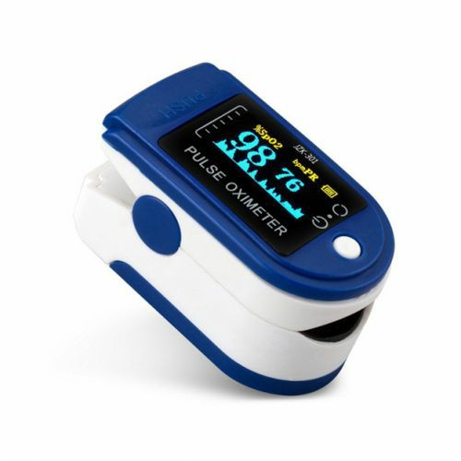

* It is a inventive device used to measure blood oxygen levels and can also display heartbeat
* A pulse oximeter is MEDICAL DEVICE that indirectly monitors the oxygen saturation of a patient’s blood
* Pulse oximeter measure:

1.The oxygen saturation of haemoglobin in arterial blood

2.The pulse rate-in beats per minute

* It is safe method and simple method of assessing oxygenation
* Convenient and measurement can be continuous
* The maintenance of optimal 02 delivery is the core concern during anaesthesia
* The pulse oximeter uses a cold light source that shines a light through the fingertip, making the tip appear to be red. By analyzing the light from the light source that passes through the finger.

ELECTROCARDIOGRAPH:

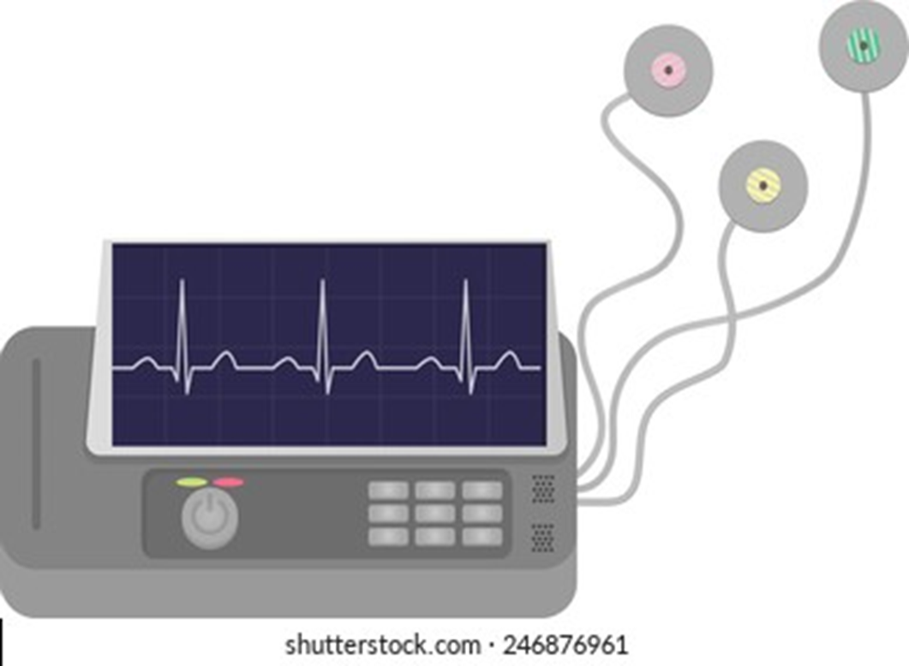

* The ecg machine is designed to recognise and record any electrical activity within the heart
* It provide information about the function of the intracardiac conducting tissue of the heart and reflcts the presence of cardiac disease through its electrical properties
* With each heartbeat,an electrical impulse starts from the superior part of the heart to the bottom.the impulse prompts the heart to contract and pumps blood
* Understanding ecg helps to understand how the heart works
* Electrical activity has two phases:

1.phase of depolaraisation

2.phase of repolarisation

* The overall direction of depolarization and repolarization produces positive or negative deflection on each lead's trace. and this phenomenon is called isoelectric.

COMPONENTS REQUIRED

* ARDUINO UNO
* AD8232 ECG SENSOR
* MX30100 SENSOR
* NODEMCU ESP8266
* JUMPER WIRES

ARDUINO UNO:

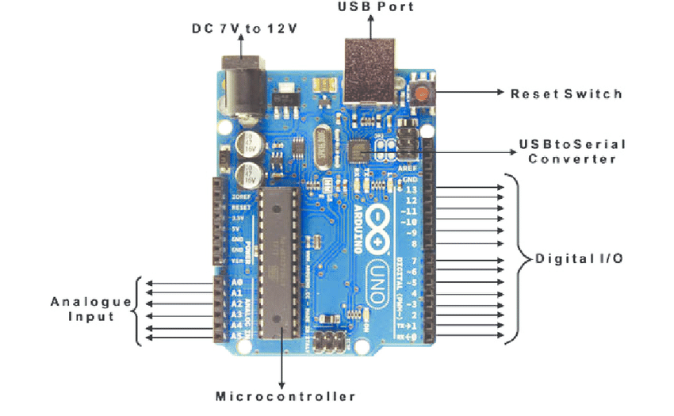

* The Arduino uno is an open source microcontroller board based on the microchip ATmega328P microcontroller and developed by aurdino.cc and initially released in 2010.
* The board is equipped with sets of digital and analog input or output pins that may be interfaced to various expansion board and circuits

|  |  |
| --- | --- |
| * **Microcontroller** | **ATmega38P – 8 bit AVR family microcontroller** |
| Input Voltage Limits | 6-20V |
| Analog Input Pins | 6 (A0-A5) |
| Digital I/O Pins | 14 (Out of which 6 provide PWM output) |
|  |  |

AD8232 ECG SENSOR:

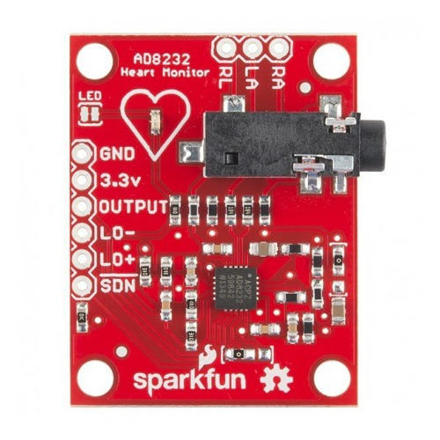

* The AD8232 ECG sensor is a commercial board used to calculate the electrical movement of the human heart.
* Electrocardiograms can be very noisy, so to reduce the noise the AD8232 chip can be used.
* The working principle of the ECG sensor is like an operational amplifier to help in getting a clear signal from the intervals simply.
* The basic principle of the ECG is that stimulation of a muscle alters the electrical potential of the muscle fibres. Cardiac cells, unlike other cells, have a property known as automaticity, which is the capacity to spontaneously initiate impulses.

MAX30100 SENSOR:

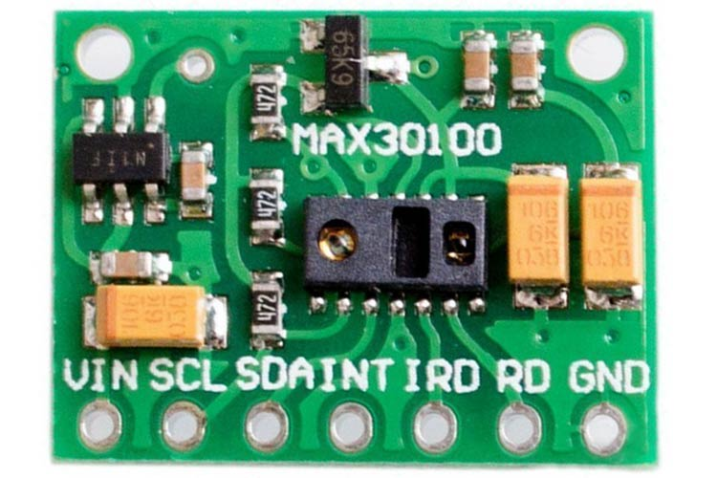

* MAX30100 is an integrated pulse oximeter and heart rate monitor sensor solution.
* It combines and two LED’s photodetector, optimized optics and low-noise analog signal processing to detect pulse oximeter and heart-rate signals. The sensor has two light-emitting diodes and one photodiode. The LED’s are used to emit the light
* The MAX30100 chip requires two different supply voltages: 1.8V for the IC and 3.3V for the RED and IR LEDs. So the module comes with two linear voltage regulators – U1 and U2. The first generates **5V to 3.3V**. The second regulator is connected to the output of the first and generates 1.8V.

NODEMCU:

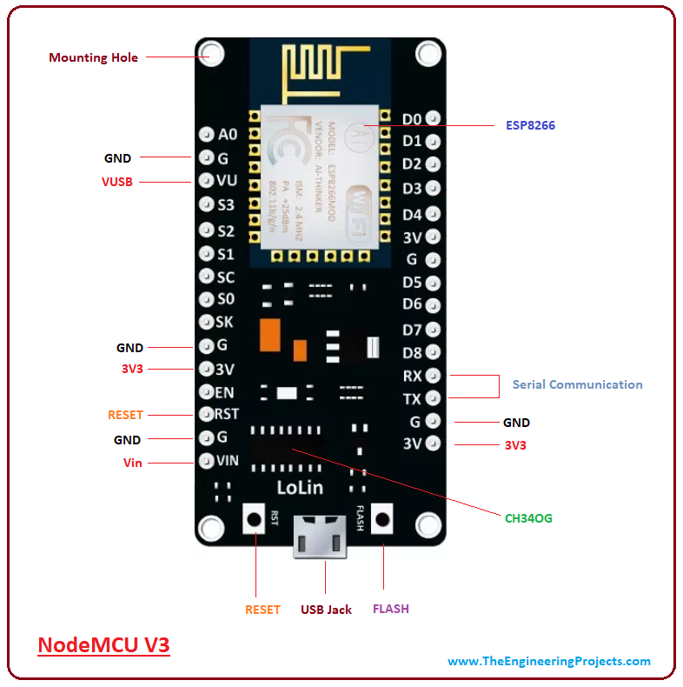

* Node MCU is an open source platform based on ESP8266 which can connect objects and let data transfer using the Wi-Fi protocol.
* In addition, by providing some of the most important features of microcontrollers such as GPIO, PWM, ADC .
* The advantages of Node MCU are low cost, integrated support for WIFI networks, a smaller board size, and lower energy
* The Node MCU is an open source software and hardware development environment that is built around a very inexpensive System-on-a-Chip (SoC) called the ESP8266.

WORKING PRINCIPLE OF ECG:

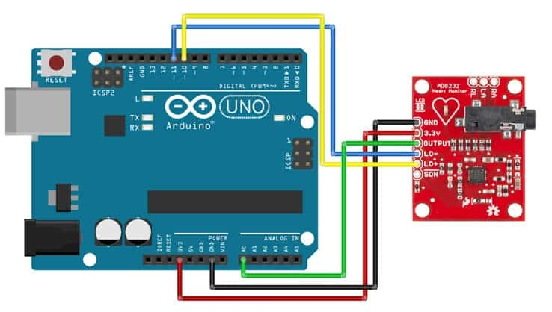

* It works on the principle that a contracting muscle generates a small electric current that can be detected and measured through electrodes suitably placed on the body.
* The electrode picks up the current and transmit them to an amplifier inside the electrocardiograph. Then electrocardiograph amplifies the current and records them on a paper as a wavy line.
* In an electrocardiograph, a sensitive lever traces the changes in current on a moving sheet of paper.
* A modern electrocardiograph may also be connected to an oscilloscope, an instrument that display the current on a screen.

WORKING PRINCIPLE OF PULSE OXIMETER:

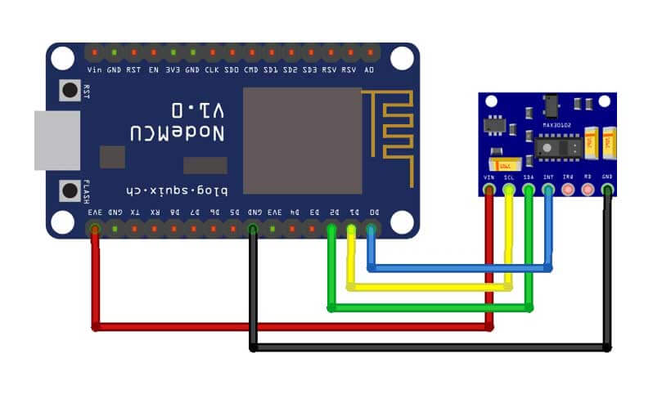

* The device has two LEDs, one emitting red light, another emitting infrared light. For pulse rate, only the infrared light is needed. Both the red light and infrared light is used to measure oxygen levels in the blood.
* When the heart pumps blood, there is an increase in oxygenated blood as a result of having more blood. As the heart relaxes, the volume of oxygenated blood also decreases. By knowing the time between the increase and decrease of oxygenated blood, the pulse rate is determined.
* It turns out, oxygenated blood absorbs more infrared light and passes more red light while deoxygenated blood absorbs red light and passes more infrared light.

SOURCE CODE OF ECG:

* void setup() {
* // initialize the serial communication:
* Serial.begin(9600);
* pinMode(10, INPUT); // Setup for leads off detection LO +
* pinMode(11, INPUT); // Setup for leads off detection LO -
* }
* void loop() {
* if((digitalRead(10) == 1)||(digitalRead(11) == 1)){
* Serial.println('!’);
* //serial.println(analogRead(A0);
* }
* else{
* // send the value of analog input 0:
* Serial.println(analogRead(A0));
* }
* //Wait for a bit to keep serial data from saturating
* delay(1);
* Serial.println(analogRead(A0));
* }

SOURCE OF PULSE-OXIMETER:

* #include <Wire.h>
* #include "MAX30105.h"
* MAX30105 particleSensor;
* void setup() {
* Serial.begin(9600);
* // Initialize sensor
* if (particleSensor.begin() == false) {
* Serial.println("MAX30102 was not found. Please check wiring/power.");
* while (1);
* }
* particleSensor.setup(); //Configure sensor. Use 6.4mA for LED drive
* }
* void loop() {
* Serial.print(" R[");
* Serial.print(particleSensor.getRed());
* Serial.print("] IR[");
* Serial.print(particleSensor.getIR());
* Serial.println("]");
* }

APPLICATIONS AND ADVANTAGES OF ECG:

* APPLICATIONS:
* 1.fitness and activity heart rate monitors
* 2.portable ECG remote health monitors
* 3.gaming peripherals
* 4.biopotential signal acquisition
* An ECG is often used alongside other tests to help diagnose and monitor conditions affecting the heart.
* The standard 12-lead electrocardiogram (ECG) is one of the most commonly used medical studies in the assessment of cardiovascular disease.11-Mar-2019
* ADVANTAGES:
* ECG helps to prevent heart attacks by analyzing heart parameters at the initial stage.
* ECG is used to detect the cardiac conditions of the patients after surgical or any other operation and after application of anesthesia.
* ECG test is quick, painless and safe.
* ECG test is cheap in cost.
* **An ECG is pretty accurate at diagnosing many types of heart disease**, although it doesn't always pick up every heart problem. You may have a perfectly normal ECG, yet still have a heart condition.

APPLICATION AND ADVANTAGES OF PULSE-OXIMETER:

* APPLICATION:
* The pulse oximeter has already found a number of clinical applications outside of the operating room, such as monitoring during patient transport, respiratory monitoring during narcotic administration, and evaluation of home-oxygen therapy.
* Pulse oximetry is a test used to measure the oxygen level (oxygen saturation) of the blood. It is an easy, painless measure of how well oxygen is being sent to parts of your body furthest from your heart, such as the arms and legs.
* ADVANTAGES:
* monitoring oxygen saturation over time.
* alerting to dangerously low oxygen levels, particularly in newborns.
* offering peace of mind to people with chronic respiratory or cardiovascular conditions.
* assessing the need for supplemental oxygen.
* A pulse oximeter is a painless device. Since there is no insertion of a needle or excessive pressure being exerted on your skin, you will not experience any pain when you are using a pulse oximeter.

ADVANCEMENTS OF ECG AND PULSE-OXIMETER:

* ECG:
* Data can be uploaded or directly sent to the doctor by using IOT technology
* By using more electrodes measurements can be more accurate
* The Advanced ECG-12C is a 3-Channel Electrocardiograph used to record the electrical activity of the heart to diagnose various heart conditions. The Advanced® ECG-12C is a convenient ECG machine that provides an excellent performance and accuracy information.
* PULSE OXIMETER:
* Obtaining accurate pulse-oximetry readings in motion and low perfusion states, the development of a central sensor probe, miniaturization, and wireless technology are the future focus points for the ongoing development of pulse oximetry
* Today, pulse oximeters have the ability to be used for hemodynamic management, regional anaesthesia, haemoglobin monitoring, and carboxyhaemoglobin and methaemoglobin detection. The new generation of pulse oximeters can provide accurate measurements in challenging situations such as low perfusion.
* The photo plethysmographic waveform is used to analyse new parameters that may have significant impacts on future clinical practice, new plethysmograph-derived parameters and light transmission-related technologies will be developed.

EXPECTED RESULT

* RESULT OF ECG: If the test is normal, it should show that your heart is beating at an even rate of 60 to 100 beats per minute.
* Many different heart conditions can show up on an ECG, including a fast, slow, or abnormal heart rhythm, a heart defect, coronary artery disease, heart valve disease, or an enlarged heart.

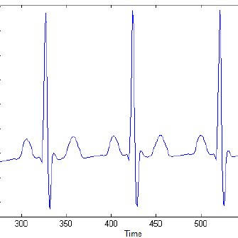

* RESULT OF PULSE-OXIMETER:
* A normal level of oxygen is usually 95% or higher. Some people with chronic lung disease or sleep apnea can have normal levels around 90%.
* The “SpO2” reading on a pulse oximeter shows the percentage of oxygen in someone's blood. If your home SpO2 reading is lower than 95%, call your health care provider

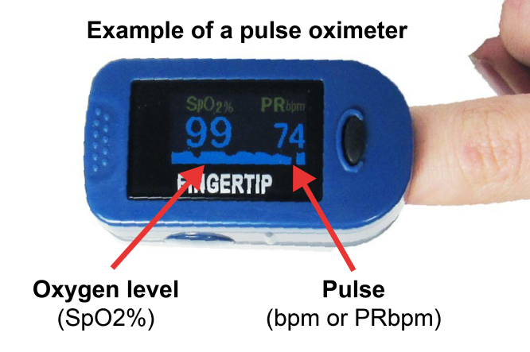.

CONCLUSION

* CONLUSION OF ECG:
* The 12-lead surface ECG can indicate pathological changes even before structural changes in the heart can be diagnosed by other methods. The recording of an ECG was of great value for several past generations of cardiologists and continues to provide vital information.
* Many different heart conditions can show up on an ECG, including a fast, slow, or abnormal heart rhythm, a heart defect, coronary artery disease, heart valve disease, or an enlarged heart. An abnormal ECG may also be a sign that you've had a heart attack in the past, or that you're at risk for one in the near future.
* CONCLUSION OF PULSE-OXIMETER:
* pulse oximetry is a simple and non- invasive way to measure blood oxygen levels and heart rate. These measurements can be used to help monitor general health and quickly assess people with lung and heart disorders.
* A normal resting heart rate for adult’s ranges from **60 to 100 beats per minute**. Generally, a lower heart rate at rest implies more efficient heart function and better cardiovascular fitness.

REFERENCE

* [Electrocardiography in Clinical Practice: Adult and Pediatric](https://www.amazon.com/Chous-Electrocardiography-Clinical-Practice-Pediatric/dp/1416037748/?_encoding=UTF8&camp=1789&creative=9325&linkCode=ur2&tag=lifinthefas-20) by Borys Surawicz and Timothy Knilans The bible of ECG interpretation.
* [Marriott’s Practical Electrocardiography](https://www.amazon.com/Marriotts-Practical-Electrocardiography-Galen-Wagner/dp/1451146256/?_encoding=UTF8&camp=1789&creative=9325&linkCode=ur2&tag=lifinthefas-20) by Galen S. Wagner Another comprehensive reference text on ECG interpretation
* Checketts MR. AAGBI recommendations for standards of monitoring during anaesthesia and recovery 2015. Anaesthesia. 2016 Apr;71(4):470-1.
* Merchant R, Chartrand D, Dain S, Dobson J, Kurrek M, LeDez K, Morgan P, Shukla R., Canadian Anesthesiologists' Society. Guidelines to the Practice of Anesthesia Revised Edition 2012. Can J Anaesth. 2012 Jan;59(1):63-102.
* <https://youtu.be/01y_Vu_sAQU>
* https://lastminuteengineers.com/max30102-pulse-oximeter-heart-rate-sensor-arduino-tutorial/